Schema CodedAttribute.xsd

attribute form default: | unqualified
element form default: | qualified
targetNamespace: | http://sdpi-biceps-extensions

Elements | Complex types
CodedDecimalAttribute | CodedDecimalAttributeType
CodedIntegerAttribute | CodedIntegerAttributeType
CodedStringAttribute | CodedStringAttributeType

element CodedDecimalAttribute
diagram | 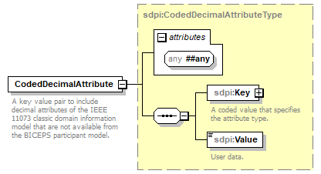
namespace | http://sdpi-biceps-extensions
type | sdpi:CodedDecimalAttributeType
properties
  content | complex
children | sdpi:Key sdpi:Value
attributes
  Name | Type | Use | Default | Fixed

element CodedIntegerAttribute
diagram | 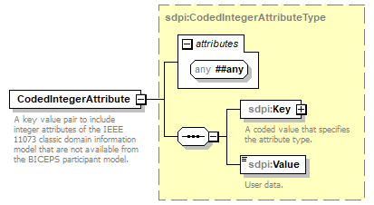
namespace | http://sdpi-biceps-extensions
type | sdpi:CodedIntegerAttributeType
properties
  content | complex
children | sdpi:Key sdpi:Value
attributes
  Name | Type | Use | Default | Fixed

element CodedStringAttribute
diagram | 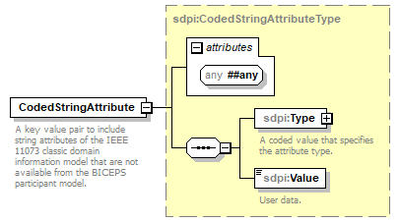
namespace | http://sdpi-biceps-extensions
type | sdpi:CodedStringAttributeType
properties
  content | complex
children | sdpi:Type sdpi:Value
attributes
  Name | Type | Use | Default | Fixed

complexType CodedDecimalAttributeType
diagram | 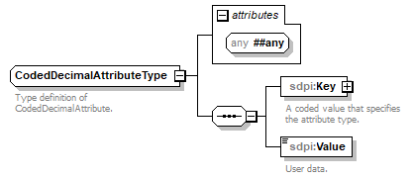
namespace | http://sdpi-biceps-extensions
children | sdpi:Key sdpi:Value
used by
  element | CodedDecimalAttribute
attributes
  Name | Type | Use | Default | Fixed

element CodedDecimalAttributeType/Key
diagram | 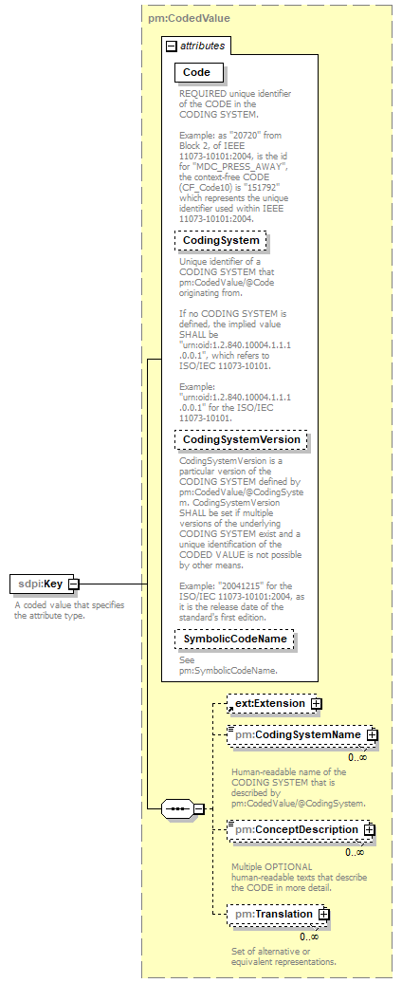
namespace | http://sdpi-biceps-extensions
type | pm:CodedValue
properties
  isRef | 0
  content | complex
children | tns:Extension pm:CodingSystemName pm:ConceptDescription pm:Translation
attributes
  Name | Type | Use | Default | Fixed
  Code | pm:CodeIdentifier | required
  CodingSystem | xsd:anyURI
  CodingSystemVersion | xsd:string
  SymbolicCodeName | pm:SymbolicCodeName

element CodedDecimalAttributeType/Value
diagram | 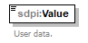
namespace | http://sdpi-biceps-extensions
type | xsd:decimal
properties
  isRef | 0
  content | simple

complexType CodedIntegerAttributeType
diagram | 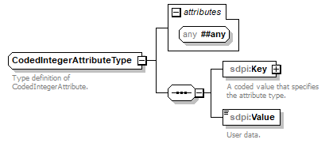
namespace | http://sdpi-biceps-extensions
children | sdpi:Key sdpi:Value
used by
  element | CodedIntegerAttribute
attributes
  Name | Type | Use | Default | Fixed

element CodedIntegerAttributeType/Key
diagram
namespace | http://sdpi-biceps-extensions
type | pm:CodedValue
properties
  isRef | 0
  content | complex
children | tns:Extension pm:CodingSystemName pm:ConceptDescription pm:Translation
attributes
  Name | Type | Use | Default | Fixed
  Code | pm:CodeIdentifier | required
  CodingSystem | xsd:anyURI
  CodingSystemVersion | xsd:string
  SymbolicCodeName | pm:SymbolicCodeName

element CodedIntegerAttributeType/Value
diagram
namespace | http://sdpi-biceps-extensions
type | xsd:integer
properties
  isRef | 0
  content | simple

complexType CodedStringAttributeType
diagram | 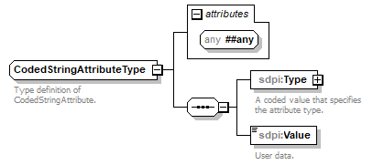
namespace | http://sdpi-biceps-extensions
children | sdpi:Type sdpi:Value
used by
  element | CodedStringAttribute
attributes
  Name | Type | Use | Default | Fixed

element CodedStringAttributeType/Type
diagram | 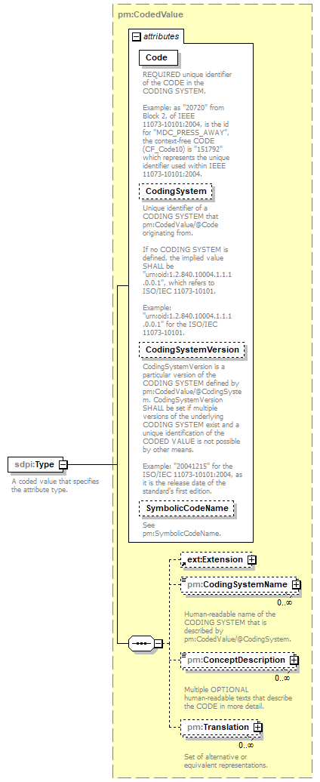
namespace | http://sdpi-biceps-extensions
type | pm:CodedValue
properties
  isRef | 0
  content | complex
children | tns:Extension pm:CodingSystemName pm:ConceptDescription pm:Translation
attributes
  Name | Type | Use | Default | Fixed
  Code | pm:CodeIdentifier | required
  CodingSystem | xsd:anyURI
  CodingSystemVersion | xsd:string
  SymbolicCodeName | pm:SymbolicCodeName

element CodedStringAttributeType/Value
diagram
namespace | http://sdpi-biceps-extensions
type | xsd:string
properties
  isRef | 0
  content | simple

XML Schema documentation generated by XMLSpy Schema Editor http://www.altova.com/xmlspy

